**Ranjit Chandrakant Sule**

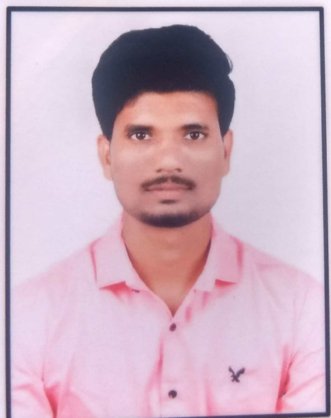

|  |  |
| --- | --- |
| **Title:** | **Associate / Software Associate** |
| **Location:** | **Mumbai, India** |
| **Languages:** | Marathi,English,Hindi |

# Career Objective

To enhance my knowledge, abilities and skills at the organizational level with my fullest dedication for the achievement of personal and organization goal.

# Key Skills

* **Functional:** Quick Learner, Teamwork, Strategic/Tactical Planning, Attentive, Good listener, Problem Solver.
* **Technical:** Java Programming, HTML, CSS, JavaScript, C#, Selenium, MySQL, Jira, GitHub.

# Software Testing Skill Summary

* Good knowledge of **Manual Testing** and **Automation Testing**.
* Well versed with **SDLC, STLC** and **Defect Life Cycle.**
* Good knowledge of **Black Box Testing** and **White Box Testing.**
* *Good Knowledge of Test Cases, Test scenario, Test Plan, Test Design and Traceability Matrix.*
* Good knowledge of **Functional** and **Non-functional Testing.**
* *Good knowledge of Regression and Re-Testing, System Integration Testing, Unit Testing Performance Testing.*
* Expertise in developing **Automation Tests** with **SELENIUM WEBDRIVER.**
* Having knowledge in **Automation Test Framework**.
* Good knowledge of **Java.**
* Good knowledge of **SQL.**

# Training, Certifications & Affiliations

* Full Stack Java : Successfully Completed Full Stack Java Program at Symbiosis Skills & Professional University, Pune.
* Completed Agile Software Development Certificate on Coursera.
* Completed Get started with Jira Certificate on Coursera
* Completed SQL, Java, JavaScript, Python Certification from HackeRank.
* Completed TOSCA(AS L1) Certification from Tricentis Academy.
* Completed Training on Selenium + Java.

# Projects

|  |  |  |
| --- | --- | --- |
| Project Name | Country Delight (Selenium & C#) | |
| Role | Team Member | |
| Roles performed | Manual + Automation testing of Login & Vacation Page | |
| Technology used in project | BDD Framework | Gherkin |
| C# & Selenium |  |
| Description | Experienced in Testing Automation Framework using Cucumber BDD, Gherkin, C#, and Selenium WebDriver. | |

# Higher Education

* Bachelor of Business Administration in Computer Application (BBA-CA) University SPPU (2019 - 2022) Percentage (80%)

# Contact Details

* Name: Ranjit Chandrakant Sule
* Permanent Address: At-Post Akulgaon, Tel- Madha, Dist- Solapur.
* Mobile: 9130060317
* Corporate Email: ranjit.sule@capgemini.com